***********************Back up*********************************************

1.  Get the prometheus object   
[root@com-kube-master ~]# kubectl -n monitoring get prometheus

NAME                                    VERSION   REPLICAS   AGE

prometheus-kube-prometheus-prometheus   v2.24.0   1          7d3h

2. Enable admin api

[root@com-kube-master ~]# kubectl -n monitoring patch prometheus prometheus-kube-prometheus-prometheus --type merge --patch '{"spec":{"enableAdminAPI":true}}'

prometheus.monitoring.coreos.com/prometheus-kube-prometheus-prometheus patched

[root@com-kube-master ~]#

3.Check the status of admin api

[root@com-kube-master ~]# kubectl -n monitoring get sts prometheus-prometheus-kube-prometheus-prometheus -o yaml | grep admin

        - --web.enable-admin-api

[root@com-kube-master ~]#

4.Port fwd

kubectl -n monitoring port-forward svc/prometheus-kube-prometheus-prometheus 9090:9090

ps -ef|grep port-forward

5.Take the snapshot

[root@COMP-4590-1 ~]# curl -XPOST <http://127.0.0.1:9090/api/v2/admin/tsdb/snapshot>

{"name":"20210324T103138Z-727a71f52257bb7d"}[root@COMP-4590-1 ~]#

6.snapshot path

[root@COMP-4590-1 snapshots]# pwd

/kubernetes-pv/local-storage-prometheus/prometheus-db/snapshots

[root@COMP-4590-1 snapshots]#

*********Restore********************************

docker run -p 9090:9090 prom/prometheus

C:\Users\pravinprakash.patil>docker ps

CONTAINER ID        IMAGE               COMMAND                  CREATED             STATUS              PORTS                    NAMES

12bfdb304564        prom/prometheus     "/bin/prometheus --c…"   7 hours ago         Up 7 hours          0.0.0.0:9090->9090/tcp   serene_wozniak

docker cp C:\Users\pravinprakash.patil\Documents\prometheusdb_snapshot.tar\prometheusdb_snapshot\snapshots\20210329T154039Z-6787bbda69449dbc\01F1A097SZ5ZF1ZFXEES9CD9DJ 12bfdb304564:/prometheus

C:\Users\pravinprakash.patil\Downloads>docker exec -it <container_name>  /bin/sh

/prometheus $

Original

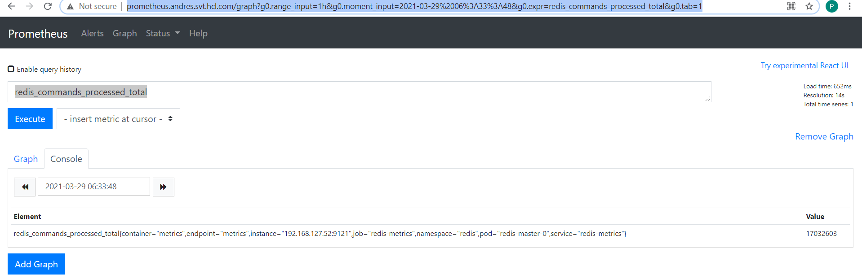

After restore

